ICH HARMONISED GUIDELINE
GENERAL CONSIDERATIONS FOR CLINICAL STUDIES (Draft version, Endorsed on 8 May 2019)
ICH E8(R1) 指引意見彙整表
段落 | 標題 | 內文(摘自E8(R1) draft guideline，仍以ICH文件為準) | 相關建議及意見  (請提供中英文內容)，  並請選擇該建議或意見之類別
1 | OBJECTIVES OF THIS DOCUMENT | Clinical studies of medical interventions are conducted to provide information that can ultimately improve access to safe and effective drugs with meaningful impact on patients, while protecting those participating in the studies. This document focuses on designing quality into clinical studies, considering the diversity of clinical study designs and data sources used to support regulatory and other health policy decisions.  The ICH document "General Considerations for Clinical Studies" is intended to:  - Describe internationally accepted principles and practices in the design and conduct of clinical studies that will facilitate acceptance of data and results by regulatory authorities  - Provide guidance on the consideration of quality in the design and conduct of clinical studies across the product lifecycle, including the identification during study planning of factors that are critical to the quality of the study, and the management of risks to  those factors during study conduct  - Provide an overview of the types of clinical studies performed during the product lifecycle, and describe the aspects of those studies that support the determination of which quality factors are critical to ensuring the protection of study subjects, the integrity of the data, the reliability of results, and the ability of the studies to meet their objectives  - Provide a guide to the ICH efficacy documents to facilitate user's access (Annex 2 and 3)  General principles of clinical study design are described in Section 2 of this document, followed by a discussion of designing quality into clinical studies in Section 3. A broad overview of planning a clinical development programme, the types of studies and study objectives that are important at different points in the programme, and issues of study feasibility from the perspective of sponsors, investigators, regulatory authorities, and patients are provided in Section 4. In Section 5, the elements composing study design are described. Section 6 describes study conduct, ensuring the safety of human subjects, and study reporting. A general discussion of identifying critical to quality factors for a study is provided in Section 7.  For the purposes of this document, a clinical study is meant to refer to a study of a medicinal product in humans, conducted at any point in a product’s lifecycle. The term "drug" should be considered synonymous with "medicinal product,” including vaccines and biological products. The term “drug approval” refers to obtaining marketing authorization for the drug. | 意見或建議：  類別 勾選  Issue  Question  Suggestion  Topic not addressed  Typographical Error  Not applicable  Other
2  2.1 | GENERAL PRINCIPLES  Protection of Clinical Study Subjects | Important principles of ethical conduct of clinical studies and the protection of subjects, including special populations, are stated in other ICH guidelines (ICH E6 Good Clinical Practice, ICH E7 Clinical Trials in Geriatric Populations, ICH E11 Clinical Trials in the Pediatric Population, and ICH E18 Genomic Sampling).  These principles have their origins in the Declaration of Helsinki and should be observed in the conduct of all human clinical investigations. The investigator and sponsor share responsibility for the protection of study subjects together with the Institutional Review Board/Independent Ethics Committee.  The confidentiality of information that could identify subjects should be protected in accordance with the applicable regulatory and legal requirement(s).  Before initiating a clinical study, sufficient information should be available to ensure that the drug is acceptably safe for the planned study in humans. Emerging clinical and non-clinical data should be reviewed and evaluated, as they become available, by qualified experts to assess the potential implications for the safety of study subjects. Ongoing and future studies should be appropriately adjusted as needed, to take new knowledge into consideration and to protect study subjects. | 意見或建議：  類別 勾選  Issue  Question  Suggestion  Topic not addressed  Typographical Error  Not applicable  Other
2.2 | Scientific Approach in Clinical Study Design, Conduct, and Analysis | Clinical studies should be designed, conducted, and analysed according to sound scientific principles to achieve their objectives, and should be reported appropriately. The essence of clinical research is to ask important questions and answer them with appropriate studies. The primary objective of any study should be clear and explicitly stated.  Quality of a clinical study is considered in this document as fitness for purpose. The purpose of a clinical study is to generate reliable information to answer key questions and support decision making while protecting study subjects. The quality of the information generated should therefore be sufficient to support good decision making.  Quality by design in clinical research sets out to ensure that the quality of a study is driven proactively by designing quality into the study protocol and processes. This involves the use of a prospective, multidisciplinary approach to promote the quality of protocol and process design, and clear communication of how this will be achieved.  Across the product lifecycle, different types of studies will be conducted with different objectives and designs. Depending on the study objectives and the position of the study in the overall development plan, the data sources may vary. For purposes of this guideline, the development plan is considered to cover the entire product lifecycle and include non-clinical, clinical, and post-approval studies (Section 4). Annex 1 provides a broad categorisation of study type by objective within the different stages of drug development.  The cardinal logic behind serially conducted studies is that the results of prior studies should inform the plan of later studies. Emerging data will frequently prompt a modification of the development strategy. For example, results of a confirmatory study may suggest a need for additional human pharmacology studies. | 意見或建議：  類別 勾選  Issue  Question  Suggestion  Topic not addressed  Typographical Error  Not applicable  Other
2.3 | Patient Input into Study Design | Consulting with patients and/or patient organisations in the design, planning and conduct of clinical studies helps to ensure that all perspectives are captured. Patients’ views can be requested on all phases of drug development. Involving patients at the early stage of study design is likely to increase trust in the study, facilitate recruitment, and promote adherence, which should continue throughout the duration of the study. Patients also provide their perspective of living with a condition, which contributes to the determination of endpoints that are meaningful to patients, selection of the right population, duration of the study, and use of the right comparators. This ultimately supports the development of medicines that are better tailored to patients’ needs. | 意見或建議：  類別 勾選  Issue  Question  Suggestion  Topic not addressed  Typographical Error  Not applicable  Other
3  3.1 | DESIGNING QUALITY INTO CLINICAL STUDIES  Quality by Design of Clinical Studies | The quality by design approach to clinical research (section 3.1) involves focusing on critical to quality factors to ensure the protection of study subjects, the generation of reliable and meaningful results, and the management of risks to those factors (section 3.2). The approach is supported by the establishment of an appropriate framework for the identification and review of critical to quality factors (section 3.3).  Quality is a primary consideration in the design, planning, conduct and analysis of clinical studies and a necessary component of clinical development programmes. The likelihood that a clinical study will answer the research questions posed in a reliable manner, meaningful for decision makers and patients, while preventing important errors, can be dramatically improved through prospective attention to the design of all components of the study protocol, procedures and associated operational plans.  Quality should rely on good design and its execution rather than overreliance on retrospective document checking, monitoring, auditing or inspection. These activities are an important part of a quality assurance process but are not sufficient to ensure quality of a clinical study. Good planning and implementation of a clinical study derive from attention to well-established principles of clinical research, which include the protection of the rights, safety and wellbeing of study subjects and scientific criteria, such as:  • the need for clear pre-defined study objectives that address the primary scientific question(s);  • selection of appropriate subjects that have the disease, condition, or molecular/genetic profile that is being studied;  • use of approaches to minimize bias, such as randomisation, blinding or masking, and/or control of confounding;  • endpoints that are well-defined and measurable, and methods of assessment of those endpoints that are accurate and able to be implemented with minimal reporting or measurement bias.  Operational criteria are also important, such as ensuring a clear understanding of the feasibility of the study, selection of suitable investigator sites, quality of specialised analytical and testing facilities and procedures, and processes that ensure data integrity. | 意見或建議：  類別 勾選  Issue  Question  Suggestion  Topic not addressed  Typographical Error  Not applicable  Other
3.2 | Critical to Quality Factors | A basic set of factors relevant to ensuring study quality should be identified for each study. Emphasis should be given to those factors that stand out as critical to study quality. These critical to quality factors are attributes of a study whose integrity is fundamental to the protection of study subjects, the reliability and interpretability of the study results, and the decisions made based on the study results. These quality factors are considered to be critical because, if their integrity were to be undermined by errors of design or conduct, the reliability or ethics of decision-making would also be undermined.  The design of a clinical study should reflect the state of knowledge and experience with the drug; the condition to be treated, diagnosed or prevented; the underlying biological mechanism (of both the condition and the treatment); and the population for which the drug is intended. As research progresses, knowledge increases and uncertainties about the safety and efficacy of a drug decrease.  This state of knowledge has a clear influence on the regulatory and ethical controls that apply to the authorisation, supervision, and conduct of clinical studies. Knowledge of the drug at the point in development when the study is designed or reviewed will therefore inform the identification of critical to quality factors and control processes used to manage them.  The sponsor and other parties designing quality into a clinical study should identify the critical to quality factors. Having identified those factors, it is important to determine the risks that threaten their integrity, the probability and impact of those risks and to decide whether they can be accepted or should be mitigated. Where it is decided that risks should be mitigated, the necessary control processes should be put in place and communicated, and the necessary action taken to mitigate the risks. The term risk is used here in the context of general risk management methodology to all factors of a study.  Proactive communication of the critical to quality factors and risk mitigation activities will support understanding of priorities and resource allocation by the sponsor and investigator sites. Proactive support (e.g., broad training to all relevant site staff and description in the protocol or in the case report form) will enhance correct implementation of study protocol, procedures, and associated operational plans and process design.  Perfection in every aspect of an activity is rarely achievable or can only be achieved by use of resources that are out of proportion to the benefit obtained. The quality factors should be prioritized to identify those that are critical to the study, at the time of the study design, and study procedures should be proportionate to the risks inherent in the study and the importance of the information collected. The critical to quality factors should be clear and should not be cluttered with minor issues (e.g., due to extensive secondary objectives or processes/data collection not linked to the proper protection of the study subjects and/or primary study objectives). | 意見或建議：  類別 勾選  Issue  Question  Suggestion  Topic not addressed  Typographical Error  Not applicable  Other
3.3  3.3.1 | Approach to Identifying the Critical to Quality Factors  Establishing a Culture that Supports Open Dialogue | A key aspect of a quality approach to study design is to ask whether the objectives being addressed by the study are clearly articulated; whether the study is designed to meet the need it sets out to address; whether these needs are meaningful to patients; and whether the study hypotheses are specific, timely and scientifically valid. The approach should consider whether those objectives can be met, well and most efficiently, by the chosen design and data sources. Study designs should be operationally feasible and avoid unnecessary complexity and unnecessary data collection. Patient consultation early in the study design process contributes to these factors and would be likely to result in fewer protocol amendments. Protocols and case report forms/data collection methods should enable the study to be conducted as designed.  Identification of critical to quality factors will be enhanced by approaches that include the following elements:  Create a culture that values and rewards critical thinking and open dialogue about quality and that goes beyond sole reliance on tools and checklists.  Choose quality measures and performance indicators that are aligned with a proactive approach to design. For example, an overemphasis on minimising the time to first patient enrolled may result in devoting too little time to identifying and preventing errors that matter through careful design.  Encourage proactive dialogue about what is critical to quality for a particular study or development programme and, when needed, the development of innovative methods for ensuring quality.  Discourage inflexible “one size fits all” approaches that undermine creation of specific strategies and actions intended to effectively and efficiently support quality in a given study.  Gather and synthesise evidence in a transparent manner, acknowledge gaps in data and conflicting data where present and known, and anticipate the possible emergence of such gaps or conflicts. | 意見或建議：  類別 勾選  Issue  Question  Suggestion  Topic not addressed  Typographical Error  Not applicable  Other
3.3.2 | Focusing on Activities Essential to the Study | Focus effort on activities that are essential to the reliability and meaningfulness of study outcomes for patients, and the safe, ethical conduct of the study for study subjects. Consider whether nonessential activities may be eliminated from the study to simplify conduct, improve study efficiency, and target resources to critical areas.  Rigorously evaluate the study design to verify that planned activities and choice of data to be collected are essential.  Deploy resources to identify and prevent or control errors that matter. | 意見或建議：  類別 勾選  Issue  Question  Suggestion  Topic not addressed  Typographical Error  Not applicable  Other
3.3.3 | Engaging Stakeholders in Study Design | Clinical study design is best informed by input from a broad range of stakeholders, including patients and treating physicians. It should be open to challenge by subject matter experts and stakeholders from outside, as well as within, the sponsor organisation.  The process of building quality into the study may be informed by participation of those directly involved in successful completion of the study such as clinical investigators, study coordinators and other site staff, and patients/patient organisations. Clinical investigators and potential study subjects have valuable insights into the feasibility of enrolling subjects who meet proposed eligibility criteria, whether scheduled study visits and procedures may be overly burdensome and lead to early dropouts, and the general relevance of study endpoints and study settings to the targeted patient population (See Section 4.4). They may also provide insight into the value of a treatment in the context of ethical issues, culture, region, demographics, and subgroups within a targeted patient population.  When a study has novel elements considered critical to quality (e.g., defining patient populations, procedures, or endpoints), early engagement with regulatory authorities should also be considered. | 意見或建議：  類別 勾選  Issue  Question  Suggestion  Topic not addressed  Typographical Error  Not applicable  Other
3.3.4 | Reviewing Critical to Quality Factors | Build on accumulated experience and knowledge with periodic review of critical to quality factors to determine whether adjustments to risk control mechanisms are needed, since new or unanticipated issues may arise once the study has begun.  Pay special attention to studies designed to include adaptations and/or interim decision points during the study. These will require proactive planning and ongoing review and adjustment of critical to quality factors, and risk management. | 意見或建議：  類別 勾選  Issue  Question  Suggestion  Topic not addressed  Typographical Error  Not applicable  Other
4  4.1 | DRUG DEVELOPMENT PLANNING  Non-Clinical Studies | This section provides general principles to consider in planning a drug development programme. Efficient drug development usually requires appropriately planned interactions with regulatory authorities throughout development, both in relation to planning early as well as later studies including post-approval studies. This is particularly important for multiregional studies to ensure the study design is aligned with regional regulatory requirements.  A drug development plan describes all aspects of the development of a product from the target product profile through post-approval activities. The plan is usually prepared prospectively and updated as the development progresses and new information becomes available. The plan generally includes characterisation of formulation development, non-clinical studies required to support the evaluation of the product in human clinical studies and to support product approval, clinical studies designed to support the demonstration of efficacy and safety in the relevant patient population, studies in special populations (e.g., paediatric populations), regional considerations for product commercialisation (e.g., health technology assessments), and post-approval studies.  It is important to ensure that the experiences, perspectives, needs, and priorities of stakeholders relating to the development and evaluation of the drug throughout its lifecycle are captured and meaningfully incorporated into the development programme.  With increased globalisation of drug development programmes there is a need to consider factors that impact quality of a protocol when it is conducted in more than one region (see ICH E17 Multi-Region Clinical Trials). Early engagement with regulatory authorities to understand local/regional requirements is encouraged and will facilitate the ability to design quality into the study protocol. The results of a study are often used in regulatory submissions in multiple regions, and the design should also consider the relevance of the study results for regions otherthan the one(s) in which the study is conducted.  Clinical development programmes may also feature requirements for co-development of validated biomarkers, diagnostic testing, or devices that facilitate the safe and effective use of a drug.  An overview of the types of studies that may contribute to a development programme is provided in the table in Annex 1.  In preparing a development plan, the non-clinical information that is required for the drug should be addressed. Non-clinical information may include toxicology, carcinogenicity, pharmacology, and pharmacokinetics to support clinical trials (e.g., ICH Safety (S) Guidelines and M3 Nonclinical Safety Studies). Important considerations for determining the necessary non-clinical studies, and their timing with respect to clinical studies, depend on the physiological and toxicological characteristics of the drug. These characteristics can include the drug’s chemical or molecular properties (e.g., small-molecule, biologic/cellular/gene therapy, complex drug, and vaccine); pharmacological basis of principal effects (mechanism of action); route(s) of administration; absorption, distribution, metabolism, and excretion (ADME); physiological effects on organ systems; dose/concentration-response relationships; half-life; duration of action; and indication. Use of the drug in special populations (e.g., pregnant or breast-feeding women, children, elderly) may require additional toxicological assessments.  Before proceeding to studies in humans, there should be sufficient information to support selection of the initial human dose and safe duration of exposure, and to provide a preliminary assessment of physiological and toxicological effects of the drug. | 意見或建議：  類別 勾選  Issue  Question  Suggestion  Topic not addressed  Typographical Error  Not applicable  Other
4.2 | Quality and Formulations of Investigational Medicinal Products | Quality of investigational medicinal products is an important consideration in planning a drug development programme and is addressed in the ICH quality guidelines. Of particular importance in transitioning from non-clinical to clinical studies is the quality of the product formulation to be taken into clinical development. Formulations should be well characterised in the drug development plan, including information on bioavailability. The formulation should be appropriate for the stage of drug development. Ideally, the supply of a formulation will be adequate to allow testing in a series of studies that examine a range of doses. During drug development, different formulations of a drug may be tested. Links between formulations, established by bioequivalence studies or other means, are important in interpreting clinical study results across the development programme. Age-appropriate formulation development is a consideration when clinical studies are anticipated in paediatric populations (ICH E11). | 意見或建議：  類別 勾選  Issue  Question  Suggestion  Topic not addressed  Typographical Error  Not applicable  Other
4.3  4.3.1  4.3.1.1 | Clinical Studies  Human Pharmacology (usually referred to as Phase 1)  Estimation of Initial Safety and Tolerability | Clinical drug development, defined as studying the drug in humans, is conducted in a sequence that builds on knowledge accumulated from previous studies. Although clinical drug development is often described as consisting of four temporal phases (Phase 1-4), it is important to appreciate that the phase concept is a description, not a set of requirements. Studies may be better categorized by other design elements such as study objective (see Annex I and Section 5). It is also important to realise that the temporal phases do not imply a fixed order of studies. Drug development is ideally a logical, step-wise process in which information from small early studies is used to support and plan later larger, more definitive studies. To develop new drugs efficiently, it is essential to identify characteristics of the investigational medicine in the early stages of development and to plan an appropriate development based on this profile.  Initial studies provide an early evaluation of short-term safety and tolerability and can provide pharmacodynamic and pharmacokinetic information needed to choose a suitable dosage range and administration schedule for initial exploratory studies. Later confirmatory studies are generally larger and longer and include a more diverse study population. Dose response information may be obtained at any stage of development, from early tolerance studies, to studies of short-term pharmacodynamic effect, to large efficacy studies (ICH E4 Dose-Response Studies). Throughout development, new data may suggest the need for additional studies.  Clinical development begins with human pharmacology studies and includes the initial administration of an investigational new drug to humans.  Studies in this phase of development may be conducted in healthy volunteer subjects or in a selected population of patients who have the condition or the disease, depending on drug properties and the objectives of the development programme.  Studies typically address one or a combination of the following aspects:  The initial and subsequent administration of an investigational new drug to humans is usually intended to determine the tolerability of the dose range expected to be evaluated in later clinical studies and to determine the nature of adverse reactions that can be expected. These studies typically include both single and multiple dose administration. | 意見或建議：  類別 勾選  Issue  Question  Suggestion  Topic not addressed  Typographical Error  Not applicable  Other
4.3.1.2 | Pharmacokinetics | Characterisation of a drug's absorption, distribution, metabolism, and excretion continues throughout the development plan, but the preliminary characterisation is often a goal of Phase 1. Pharmacokinetic studies are particularly important to assess the clearance of the drug and to anticipate possible accumulation of parent drug or metabolites, and potential drug-drug interactions. Some pharmacokinetic studies are commonly conducted in later phases to answer more specialised questions. For many orally administered drugs, especially modified release products, the study of food effects on bioavailability is important. Obtaining pharmacokinetic information in sub-populations such as patients with impaired elimination (renal or hepatic impairment), the elderly, children, and ethnic subgroups should be considered (ICH E5 Ethnic Factors in the Acceptability of Foreign Clinical Data, E7, E11).  If a potential for drug-drug interaction is suggested by metabolic profile, by the results of non-clinical studies, or by information on similar drugs, studies on drug interaction during clinical development are highly recommended and may be required to inform safe use and drug labelling, especially for drugs that are frequently co-administered. This is particularly true for drugs that are known to alter the absorption or metabolism of other drugs, or whose metabolism or excretion can be altered by effects of other drugs. Drug-drug interaction studies are generally performed at later phases of development, but studies in animals and in vitro studies of metabolism and potential interactions may inform the need for earlier studies. | 意見或建議：  類別 勾選  Issue  Question  Suggestion  Topic not addressed  Typographical Error  Not applicable  Other
4.3.1.3 | Pharmacodynamics & Early Measurement of Drug Activity | Depending on the drug and the endpoint studied, pharmacodynamic studies and studies relating drug levels to response (PK/PD studies) may be conducted in healthy volunteer subjects or in patients with the target disease. If there is an appropriate measure, pharmacodynamic data can provide early estimates of activity and potential efficacy and may guide the dosage and dose regimen in later studies.  Preliminary studies of activity or potential therapeutic benefit may be conducted in Phase 1 as a secondary objective. Such studies are generally performed in later phases but may be appropriate when drug activity is readily measurable with a short duration of drug exposure in patients at this early stage. | 意見或建議：  類別 勾選  Issue  Question  Suggestion  Topic not addressed  Typographical Error  Not applicable  Other
4.3.2 | Exploratory and Confirmatory Studies (usually referred to as Phase 2 or Phase 3) | Exploratory studies (Phase 2) support clinical proof of concept for the drug in a selected population of patients who have the condition or disease for which the drug is intended. If the data are promising, then further clinical evaluation follows to confirm the early findings. These evaluations may aim to refine the effective dose(s) and therapeutic regimens (including concomitant medication) for subsequent studies, refine the definition of the target population, provide a more robust safety profile for the drug, and may include evaluation of potential study endpoints for further study. Initial exploratory studies may use a variety of study designs, including concurrent controls, comparisons with baseline status, and adaptive dose-finding. Other studies may involve modelling early or intermediate outcome data to predict clinical outcomes and thereby inform the design of the follow-on, larger confirmatory studies.  Confirmatory studies (Phase 3) are designed to confirm the preliminary evidence accumulated in earlier phases that a drug is safe and effective for use for the intended indication and recipient population. These studies are often intended to provide an adequate basis for marketing approval, and to support adequate instructions for use of the drug and official product information. They aim to evaluate the drug in a larger population of patients with or at risk of the condition or disease. These subjects more accurately represent the population of patients who will receive the drug once approved and may include subgroups of patients with frequently occurring or potentially relevant co-morbidities (e.g., cardiovascular disease, diabetes, hepatic and renal impairment) to characterise the safe and effective use of the drug in patients with these baseline conditions.  Confirmatory studies may further explore the dose-response relationship or explore the drug's use in different stages of disease or in combination with one or more drugs. If the intent is to administer a drug for a long period, studies involving extended exposure to the drug should be conducted (ICH E1 Clinical Safety for Drugs used in Long-Term Treatment). Irrespective of the duration of administration, the duration of effect of the drug will usually guide the demand for understanding long-term effects and therefore the duration of follow-up in the study.  Confirmatory studies often use randomised parallel designs. They may use complex adaptive or innovative designs to realize efficiencies or test assumptions as data accumulate during the study. | 意見或建議：  類別 勾選  Issue  Question  Suggestion  Topic not addressed  Typographical Error  Not applicable  Other
4.3.3 | Post Approval Studies (usually referred to as Phase 4) | Post approval studies are studies conducted following drug approval. They may be performed for a variety of reasons, including providing additional information on the efficacy, safety, and use of the drug. For example, in certain circumstances, a drug may be approved based on surrogate endpoints likely to predict clinical outcomes. After such an approval, studies would be conducted to demonstrate effects on clinical endpoints. Studies in special populations, such as paediatric and elderly populations, may be conducted to understand the drug effects in these populations. Safety studies may be conducted after authorization to refine the understanding of potential risks. Studies with long-term follow-up or with comparisons among authorized drugs may provide important information on safety and efficacy to the medical community. Post-approval studies encompass a range of designs and data sources (See Section 5). | 意見或建議：  類別 勾選  Issue  Question  Suggestion  Topic not addressed  Typographical Error  Not applicable  Other
4.3.4 | Additional Development | After initial approval, drug development may continue with studies of new or modified indications, new dosage regimens, new routes of administration, or additional patient populations. If a new dose, formulation or combination is studied, additional non-clinical and/or human pharmacology studies may be indicated. Data from previous studies or from clinical experience with the approved drug may inform these programmes. | 意見或建議：  類別 勾選  Issue  Question  Suggestion  Topic not addressed  Typographical Error  Not applicable  Other
4.3.5 | Consideration in Special Populations | Some groups in the general population may require special study because they have unique risk/benefit considerations that need to be taken into account during drug development, or because they can be anticipated to need modification of the dose or schedule of a drug. ICH E5 provides a framework for evaluating the impact of ethnic factors on a drug’s effect. Non-clinical safety studies to support human clinical studies in special populations may be needed (see, e.g., ICH S5 Reproductive Toxicology, S11 Nonclinical Paediatric Safety, and M3). Following are examples of special populations to be considered during development planning.  • Investigations in pregnant women  If a pregnant woman is enrolled in a clinical study, or a woman becomes pregnant while participating in a clinical study, evaluation of the pregnancy, foetus, and child, and reporting of all outcomes in the clinical study report, is often necessary. The same applies for clinical studies that include pregnant women, where the medicinal product is intended for use during pregnancy.  • Investigations in nursing women  Excretion of the drug or its metabolites into human milk should be examined where applicable and feasible. When nursing mothers are enrolled in clinical studies their babies are usually also monitored for the effects of the drug.  • Investigations in children  ICH E11 provides an outline of critical issues in paediatric drug development and approaches to the safe, efficient, and ethical study of drugs in paediatric populations.  • Investigations in geriatric populations  ICH E7 provides an outline of critical issues in geriatric drug development and approaches to the safe, efficient, and ethical study of drugs in geriatric populations.  • Investigations in renal and hepatic impaired populations  Pharmacokinetic studies in patients with renal and hepatic impairment are important to assess the impact of potentially altered drug metabolism or excretion.  Particular attention should be paid to the ethical considerations related to informed consent in vulnerable populations (ICH E6 and E11). | 意見或建議：  類別 勾選  Issue  Question  Suggestion  Topic not addressed  Typographical Error  Not applicable  Other
4.4 | Feasibility | During drug development, the feasibility of the individual studies should be assessed. The foundation of a successful study is a protocol that is both scientifically sound and operationally viable. A detailed feasibility assessment includes consideration of study design and implementation elements that could impact the successful completion of a clinical development programme or study from an operational perspective in a particular geographical region.  Consideration of critical to quality factors relating to study feasibility can inform study design and enhance quality implementation. Feasibility considerations include but are not limited to the availability of qualified investigators/site personnel with experience in conducting a clinical study; availability of equipment and facilities required to successfully conduct the clinical study; availability of the desired patient population; ability to enrol sufficient numbers of participants as determined by the study’s power analysis; the ethical and regulatory considerations, which include informed consent, parental/caregiver consent and patient assent for paediatric studies; and regional standards of care.  An important aspect of study feasibility is understanding the view of potential study subjects about protocol elements that could impact their willingness to enrol or continue participation in the study (e.g., impact of study procedures, meaningfulness of the study objectives/outcomes). The retention of study subjects and the follow-up of subjects who have withdrawn from treatment are key critical to quality factors. It is important to not underestimate the value that appropriate and early consultation with patients will have on the feasibility of the study, adherence to the protocol, and, more essentially, relevance (or suitability) for patients of the drug approval based on the accumulated knowledge and experience from the clinical studies. | 意見或建議：  類別 勾選  Issue  Question  Suggestion  Topic not addressed  Typographical Error  Not applicable  Other
5  5.1  5.1.1 | DESIGN ELEMENTS FOR CLINICAL STUDIES  Study Design  Study Population | Study objectives impact the choice of study design and data sources, which in turn impact the strength of a study to support regulatory decisions and clinical practice. This section presents important elements that define the design of a clinical study. It is intended to assist in identifying the critical to quality factors necessary to achieve the study objectives and theprotection of study subjects, while also enabling flexibility in study design and promoting efficiency in study conduct. This document does not discuss all possible study types that may be included within the drug lifecycle. The elements outlined here are expected to be relevant to study types and data sources in use in clinical studies now, and that may be developed in the future.  Clear objectives will help to determine the study design and conversely, the process of specifying the design may help to further clarify the objectives. Objectives may need to be modified as practical considerations and limitations are revealed.  The fundamental design elements of a clinical study include population, intervention, control group, response variable, methods to reduce or assess bias, and statistical analysis. The protocol brings these elements together with the study objectives, study type, and data sources (see Section 5.2), and should be finalised before the start of the study (see ICH E6).  The population to be studied should be chosen to support the study objectives and is defined through the inclusion and exclusion criteria for the study. In practice, the study population is limited to subjects available to participate and for whom consent is available (see ICH E6). Recruitment efforts should ensure that the study subjects reflect the planned population for the study. If objectives include obtaining information on certain subgroups, then efforts should be made to ensure adequate representation of these subgroups.  The study population might be narrowly defined to reduce heterogeneity and maximize the sensitivity of the study for detecting a certain effect. Conversely, it may be broadly defined to more closely represent the population for which the drug is intended. In general, studies conducted early in a development programme, when little is known about the safety of the drug, tend to be more homogeneous in study population definitions, and those conducted in the later phases of drug development or post-approval tend to be more heterogeneous. Recruitment for a precision medicine study, for example, may target the subgroup of diseased patients with a particular phenotype or genotype, either exclusively or through an enrichment study design. The choice of study population will depend on the study objectives, and the degree to which a study succeeds in recruiting and enrolling the desired population will impact the ability of the study to meet those objectives.  For example, a study population representative of clinical practice may be the target of a pragmatic trial conducted within an existing healthcare system. In such a study, recruitment procedures may differ from other types of studies, in that the inclusion and exclusion criteria may be assessed based on existing medical records.  Because of the study objectives or because of feasibility or efficiency, there may be situations in which the population unit is not an individual but a group of subjects (known as a cluster). For example, some vaccine studies make use of cluster randomisation to measure their protective effects on communities. The use of a cluster unit has implications for multiple design elements and quality factors (e.g., intervention, analysis, consent).  The study should plan to have a sufficient number of subjects to make statistical conclusions based on the findings either by obtaining a certain precision or by controlling the probabilities of making false conclusions (see ICH E9 Statistical Principles for Clinical Trials). A larger database may be needed to establish the safety of a drug (see ICH E1). | 意見或建議：  類別 勾選  Issue  Question  Suggestion  Topic not addressed  Typographical Error  Not applicable  Other
5.1.2 | Intervention | An important distinction between studies is whether the choice of the study drug and the health management of the subjects are controlled by the study (with proper regard to human subject protection and regulatory requirements) or merely observed in the study. The former case is referred to as an interventional study and the latter case is referred to as an observational study.  Interventional studies often have the potential to control biases better than observational studies (see Section 5.1.5). Factors such as study objectives, feasibility, data sources, and anticipated biases and uncertainty play a role in the choice between interventional and observational studies. Observational studies are usually conducted in the post-approval period.  There is varying overlap between interventional and observational studies. For example, a pragmatic trial is a mix of the two types in that the intervention is controlled by the study, but health management is controlled to a lesser degree than in other study types. | 意見或建議：  類別 勾選  Issue  Question  Suggestion  Topic not addressed  Typographical Error  Not applicable  Other
5.1.3 | Control Group | The drug effect of interest may be the effect relative to not receiving the drug or the effect relative to receiving other therapies. For example, comparisons may be made with placebo, no treatment, active controls or different doses of the drug under investigation. To derive these comparisons, information on a group of subjects not receiving the drug or receiving other therapies is usually needed. This group is known as the control group (see ICH E10). The choice of a control group may be influenced by the study objectives, ethical considerations, and study feasibility.  The source of control group data may be internal or external to the study. With use of an internal control group, all subjects in the study are selected by the same processes, and data are acquired by the same procedures at the same time, with the intent that the only differences observed among subjects in the study are due to the treatment they receive. With use of an external control group, subjects are selected from an external source, and the control group subjects may be treated at an earlier time (historical control group) or during the same time but in another setting than subjects in the study.  External control subjects may differ from subjects participating in the study with respect to follow-up and measurement of study outcomes and other data elements. In addition, external control subjects may differ from study subjects with respect to some demographic and background characteristics (e.g., medical history, concurrent diseases, etc.), possibly reflecting a somewhat different subject population, which should be taken into account in the design and analysis of the study.  It may be possible for a single clinical study to use both internal and external control subjects. For example, conduct of the study may be facilitated by supplementing the internal control group with additional data on an external control group.  In some circumstances, rather than using a separate group of control subjects, subjects may function as their own control receiving the drug and control at different points of time. Both interventional and non-interventional studies may make use of such an approach. Examples of this approach include crossover designs for interventional studies and case-crossover designs for non-interventional studies.  There are critical to quality factors that are associated with the choice and use of the control group, including study objective, availability and quality of control data, feasibility of conducting the study, ethical considerations, comparability between treatment and control populations, and comparability of outcome ascertainment.  Subject level data may not be available for some choices of external control groups, but if summary measures are available from the external source, they may be used to form the basis of comparisons with treated subjects to estimate and test hypotheses about drug effects. In this case, however, the critical to quality factor of comparability between treatment groups is unable to be addressed through adjustment for subject-level covariates.  When control data considered adequate to support comparisons are not available, responses to treatment observed in the study may be compared to a relevant and justified target value for the control response rate (e.g., tumour response rate in oncology; cure rate for anti-infectives). Even in cases where comparable control data are available, an external target value may still be useful in evaluating the response rate observed in the study. | 意見或建議：  類別 勾選  Issue  Question  Suggestion  Topic not addressed  Typographical Error  Not applicable  Other
5.1.4 | Response Variables | A response variable is a subject-level attribute of interest that may be affected by the drug. The response variable may relate to the pharmacokinetics, pharmacodynamics, efficacy, safety, or use of the drug post-approval including compliance with risk minimisation measures. Study endpoints are the response variables that are chosen to assess drug effects.  The choice of primary endpoint is critical to the quality of the study. The primary endpoint should be the variable capable of providing the most clinically relevant and convincing evidence directly related to the primary objective of the study, taking into account feasibility considerations (ICH E9). Secondary variables are either supportive measurements related to the primary objective or measurements of effects related to the secondary objectives. The choice of endpoints should be meaningful for the intended population and take into account the views of patients.  The definition of each study endpoint should be specific. The specificity should include how it is ascertained and at what time point in a subject’s treatment course of the drug and follow-up it is ascertained. The methods used to ascertain endpoints should be of sufficient accuracy, precision, responsiveness (sensitivity to change), reproducibility, reliability, and validity.  Pragmatic trials may make use of existing data from healthcare systems to obtain response variables rather than through study specific data collection, similar to the way healthcare data can be used to select the study population as described above (See Sec 5.1.1).  The knowledge of the drug, the clinical context, and the purpose of a given study affect what response variables should be collected. For example, a proof-of-concept study may employ short-term surrogates rather than objective clinical outcomes. Clinical outcomes would then be used to confirm a clinically meaningful effect in a large-scale confirmatory study. In other cases, for example, a post-approval study where the safety profile of the drug is well characterised, the extent of safety data collection may be tailored to the objectives of the study. | 意見或建議：  類別 勾選  Issue  Question  Suggestion  Topic not addressed  Typographical Error  Not applicable  Other
5.1.5 | Methods to Reduce or Assess Bias | The study design should address sources of bias that can undermine the reliability of results. Although different types of studies are subject to different sources of bias, this section addresses the more common sources. ICH E9 discusses principles for controlling and reducing bias mainly in the context of interventional studies.  In conducting a controlled study, randomised allocation is the preferred means of assuring comparability of test groups, thereby minimising the possibility of bias in treatment assignment.  Randomisation addresses differences between the groups at the time of randomisation but does not prevent differences arising after randomisation. Events after randomisation (intercurrent events) may also affect the comparability of the groups. For example, there may be differences in the follow-up patterns between the groups, such as subjects in one group dropping out of the study because of adverse events or lack of efficacy. Careful consideration of the potential impact of intercurrent events will help with the identification of critical to quality factors, such as preventing dropouts, retrieving data for dropouts, and definition of treatment effect in the presence of dropouts.  Concealing the treatment assignments (blinding or masking) limits the occurrence of conscious or unconscious bias in the conduct and interpretation of a clinical study that may affect the course of treatment, monitoring, endpoint ascertainment, and subject responses. A study where the treatment assignment is not known by the study participant is referred to as a single-blind study. When the investigator and sponsor staff who are involved in the treatment or clinical evaluation of the subjects are also unaware of the treatment assignments, the study is double blind. Maintaining confidentiality of interim study results also can help to reduce bias.  In an open-label study (either single-arm or unblinded comparative), the consequences of the lack of blinding may be reduced through the use of pre-specified decision rules for aspects of study conduct, such as treatment assignment, subject management, safety reporting, and response variable ascertainment.  Observational studies pose unique challenges to the control of bias. Multiple design elements are often necessary to address these challenges, including methods to address biases associated with the (1) selection of subjects, (2) differences in prognostic factors associated with the choice of therapies (confounding), and (3) ascertainment of response variables and other important study variables. | 意見或建議：  類別 勾選  Issue  Question  Suggestion  Topic not addressed  Typographical Error  Not applicable  Other
5.1.6 | Statistical Analysis | The statistical analysis of a study encompasses important elements necessary to achieving the study objectives. The study protocol should include a statistical methods section that is appropriate for the objectives and study design (ICH E6 and E9). A separate statistical analysis plan may be used to provide the necessary details for implementation. The protocol should be finalised before the conduct of the study, and the statistical analysis plan should be finalised before the unblinding of study data, or in the case of an open-label study, before the conduct of the study. These steps will increase confidence that important aspects of analysis planning were not based on accumulating data in the study or inappropriate use of external data, both of which can negatively impact the reliability of study results. For example, the choice of analysis methods in a randomised clinical trial should not change after examining unblinded study data, and external control subjects should not be selected based on outcomes to be used in comparative analyses with treated study subjects.  Statistical analyses of primary and secondary endpoints to achieve study objectives with respect to both efficacy and safety should be described, as well as any interim analyses and/or planned design adaptations (E9). The analysis plan should describe the analytical methods for the estimation and tests of hypotheses about the drug effect, addressing the method of treatment allocation, the measurement methods of response variables, the analysis population, and other critical to quality factors relating to the planned analysis strategy appropriate for the study design. The plan should address the handling of intercurrent events, such as treatment discontinuations, use of rescue medication, missed visits, and other protocol violations.  The statistical analysis plan should describe how the various sources of bias discussed above will be addressed in the context of the particular study design and data sources (see Section 5.1.5).  Pre-specification is particularly important for studies that make use of existing data sources rather than primary data collection (see Section 5.2), not only for the statistical analysis planned for the study but also for any feasibility analysis to assess the applicability of the existing data. For example, for a single arm interventional study with an external control, the specifics of the external control should be specified prior to the conduct of the interventional aspect of the study. Assurances and procedures should be in place so that any review of the data prior to the design of the study does not threaten the study integrity.  Sensitivity analyses should be planned to test the impact of the assumptions made for the primary analyses on the results of the study. For example, if the primary analysis relies on a particular assumption about the reasons data are missing, sensitivity analyses should be planned to assess the impact of those assumptions on the study results. An example for observational studies might be consideration of additional confounders. | 意見或建議：  類別 勾選  Issue  Question  Suggestion  Topic not addressed  Typographical Error  Not applicable  Other
5.2 | Study Data | The study data should reliably contain the necessary information to conduct, monitor, and analyse the study. The study data may be acquired through a variety of methods, including paper-based and electronic capture. Data from the use of technologies (e.g., digital health tools), electronic health record databases and patient registries may contribute to the development of a new investigational drug or for further evaluation of an approved drug.  Study data can be broadly classified into two types: (1) data generated specifically for the present study and (2) data obtained from sources external to the present study. The distinction between the two types may not always be clear. For example, clinical study data may be collected during scheduled study visits via case report forms, laboratory measurements, and other mechanisms, while also including information obtained from existing medical records. Data from both types of data sources comprise the clinical database in this case.  The term primary data collection, refers to data collected for study purposes using processes that ensure a sufficient level of quality. The term secondary data use, refers to the use of data that were collected for other purposes and are not collected just for the study. Note that secondary data themselves may have had careful quality control processes implemented during their acquisition, but those processes were not designed with the objectives of the present study in mind. Examples of secondary data sources that might be used in clinical studies include national death databases, disease and drug registries, claims data, and medical and administrative records from routine medical practice.  With secondary data use, the appropriateness of the available data should be considered. For example, when using existing electronic health record data to ascertain the study endpoint rather than through primary data collection, information in the health record about outcomes would need to be converted to the study endpoint. The sensitivity, specificity, and timing of the outcomes in the record should be considered. In some cases, secondary data use may not be sufficient for all aspects of the study and may need to be supplemented with primary data.  There are several additional considerations when using secondary data. Concealing the drug name in the measurement and recording of data is typically not present in secondary data use. Absence of affirmative information on a condition or event does not necessarily mean the condition is not present. For example, absence of smoking status in a medical record may not mean the patient is not a smoker. There also may be a delay between events and their presence in existing data sources.  The use of data standards for the terminology, storage, exchange, and access of study data promotes the reliability and the proper interpretation of the data. Data standards also facilitate the ease and correctness of the data analysis. International data standards exist for many sources of study data. Data standards should be developed for emerging sources of study data.  For all data sources, procedures to ensure the confidentiality of personal data should be implemented. The study design should explicitly address the protection of personal data. Local regulations related to privacy of participants’ data should be followed. | 意見或建議：  類別 勾選  Issue  Question  Suggestion  Topic not addressed  Typographical Error  Not applicable  Other
6  6.1 | CONDUCT AND REPORTING  Study Conduct | The principles and approaches set out in this guideline, including those of quality by design, should inform the approach taken to the conduct and reporting of clinical studies and the proportionality of control measures employed to ensure the integrity of the critical to quality factors. The study should be conducted according to the principles described in this guideline and in accordance with ICH E6 and other relevant ICH guidelines (see Annex 2 and Annex 3). | 意見或建議：  類別 勾選  Issue  Question  Suggestion  Topic not addressed  Typographical Error  Not applicable  Other
6.1.1 | Protocol Adherence | Adherence to the study protocol is essential, and many aspects of adherence should be considered among the study’s critical to quality factors. If modification of the protocol becomes necessary, a clear description of the rationale for the modification should be provided in a protocol amendment (ICH E6). | 意見或建議：  類別 勾選  Issue  Question  Suggestion  Topic not addressed  Typographical Error  Not applicable  Other
6.1.2 | Training | Study stakeholders, such as sponsors; investigators, coordinators, and other local site staff; site monitors; adjudicators and members of the data monitoring committee; and third-party service providers (e.g., central laboratory or reading centre personnel) should receive thorough training prior to enrolment of the first study subject. Updated training should occur during the conduct of the study to reinforce the importance of adherence to study procedures and to address issues related to critical to quality factors observed during the course of the study. | 意見或建議：  類別 勾選  Issue  Question  Suggestion  Topic not addressed  Typographical Error  Not applicable  Other
6.1.3 | Data Management | As discussed in ICH E6, the manner and timelines in which study data are collected and managed are critical contributors to overall study quality. Operational checks and statistical surveillance can identify important data quality issues at a point at which corrective action is feasible. Data management procedures should account for the diversity of data sources in use for clinical studies (see Section 5.2). | 意見或建議：  類別 勾選  Issue  Question  Suggestion  Topic not addressed  Typographical Error  Not applicable  Other
6.1.4 | Access to Interim Data | Inappropriate access to data during the conduct of the study may compromise study integrity. In studies with planned interim analyses, special attention should be given to which individuals have access to the data and results. Even in studies without planned interim analyses, special attention should be paid to any ongoing monitoring of data to avoid inappropriate access. | 意見或建議：  類別 勾選  Issue  Question  Suggestion  Topic not addressed  Typographical Error  Not applicable  Other
6.2  6.2.1 | Subject Safety  Safety Monitoring | The goals of safety monitoring are to protect study subjects and to characterize the safety profile of the drug. Procedures and systems for the identification, monitoring, and reporting of safety concerns including the timing of reporting during the study should be clearly specified. The approach should reflect the risks to the study subjects and what is known about the drug and the study population. Guidance is available on reporting of safety data to appropriate authorities and on the content of safety reports [ICH E2 Pharmacovigilance (A, B, and D), and ICH E6]. | 意見或建議：  類別 勾選  Issue  Question  Suggestion  Topic not addressed  Typographical Error  Not applicable  Other
6.2.2 | Withdrawal Criteria | Clear criteria for stopping study treatment while remaining in the study or withdrawing from the study altogether are necessary to ensure the protection of the subjects; however, consideration could be given to methods that will preserve subjects’ safety and rights while still minimising loss of critical data, if possible. | 意見或建議：  類別 勾選  Issue  Question  Suggestion  Topic not addressed  Typographical Error  Not applicable  Other
6.2.3 | Data Monitoring Committee | An important component of safety monitoring in many clinical studies is the use of a data monitoring committee (DMC). A DMC monitors accumulating data while the study is being conducted to make determinations on whether to continue, modify, or terminate a study.  During programme planning, the need for an external safety monitoring committee to monitor safety data across studies in a development programme may also be assessed. If a data monitoring committee is needed for either an individual study or the entire development  programme, procedures governing its operation and, in particular, the review of unblinded data while preserving study integrity (ICH E9) should be established. | 意見或建議：  類別 勾選  Issue  Question  Suggestion  Topic not addressed  Typographical Error  Not applicable  Other
6.3 | Study Reporting | Clinical study reports should be adequately documented following the approaches outlined in other ICH guidelines. ICH E3 focuses particularly on the report format for interventional clinical studies. Other types of studies (e.g., observational studies) should use reporting formats appropriate for the type of study and information being reported.  The transparency of clinical research in drug development includes the registration of clinical trials on publicly accessible and recognised databases, and the public posting of clinical trial results. Adopting such practices for observational studies also promotes transparency. Making objective and unbiased information publicly available can benefit public health in general, as well as individual patient populations, through enhancing clinical research, reducing unnecessary clinical studies and informing decisions in clinical practice. | 意見或建議：  類別 勾選  Issue  Question  Suggestion  Topic not addressed  Typographical Error  Not applicable  Other
7 | CONSIDERATIONS IN IDENTIFYINGCRITICAL TO QUALITY FACTORS | The identification of critical to quality factors should be supported by proactive, cross-functional discussions and decision making at the time of study planning, as described in Section 3. Different factors will stand out as critical for different types of studies, following the concepts introduced in Sections 4 through 6.  In designing a study, applicable aspects such as the following should be considered to support the identification of critical to quality factors:  • Engagement of all relevant stakeholders, including patients, is considered during study planning and design.  • The prerequisite non-clinical studies, and where applicable, clinical studies, are complete and adequate to support the study being designed.  • The study objectives address relevant scientific questions appropriate for a given study’s role in the development programme, taking into account the accumulated knowledge about the product.  • The clinical study design supports a meaningful comparison of the effects of the drug when compared to the chosen internal or external control groups.  • Adequate measures are used to protect subjects’ rights, safety, and welfare (informed consent process, Institutional Review Board/Ethics Committee review, investigator and clinical study site training, pseudonymisation, etc.).  • A feasibility assessment is conducted to ensure the study is operationally viable.  • The number of subjects included, the duration of the study, and the frequency of study visits are sufficient to support the study objective.  • The eligibility criteria should be reflective of the study objectives and be well documented in the clinical study protocol.  • Information about study subjects that may be important to understanding the benefit/risk of the drug (e.g., age, weight, sex, co-morbidities, concomitant therapies) is specified in the protocol, captured and incorporated in the design, conduct, and analysis, as appropriate.  • The choice of response variables and the methods to assess them are well-defined and support evaluation of the effects of the drug.  • Clinical study procedures include adequate measures to minimise bias (e.g., randomisation, blinding).  • The statistical analysis plan is pre-specified and defines the analysis methods appropriate for the endpoints and the populations of interest.  • Systems and processes are in place to ensure the integrity of critical study data.  • The extent and nature of study monitoring are tailored to the specific study design and objectives and the need to ensure subject safety.  • The need for a data monitoring committee is assessed.  These considerations are not exhaustive and may not apply to all studies. Other aspects may need to be considered to identify the critical to quality factors for each individual study. | 意見或建議：  類別 勾選  Issue  Question  Suggestion  Topic not addressed  Typographical Error  Not applicable  Other
ANNEX 1: | TYPES OF STUDIES | Drug development is ideally a logical, step-wise process in which information from small early studies is used to support and plan later larger, more definitive studies. In the table below, types of studies are categorized by objectives. Illustrative examples, not intended to be exhaustive, are provided. Examples appearing under one type may also occur under another.  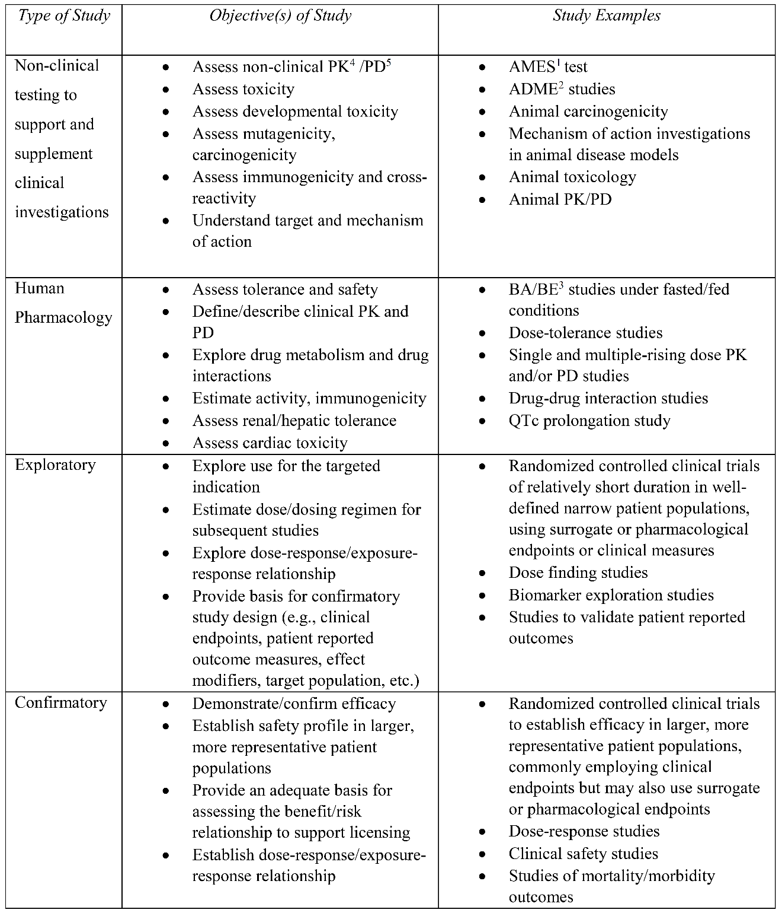  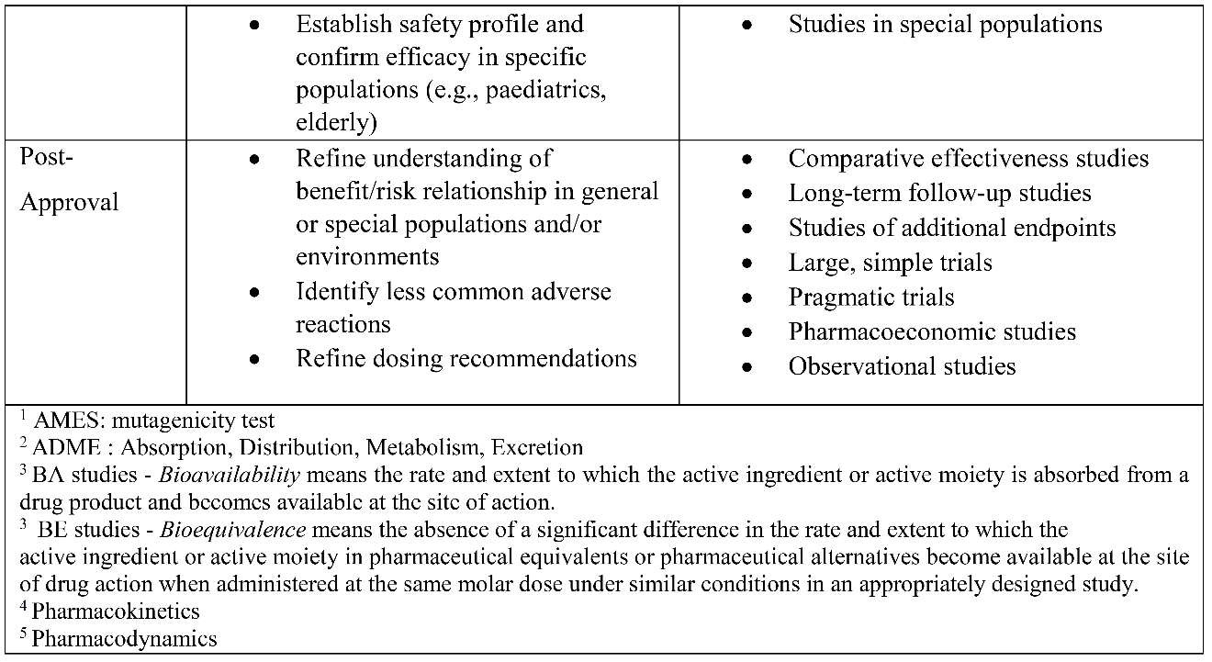 | 意見或建議：  類別 勾選  Issue  Question  Suggestion  Topic not addressed  Typographical Error  Not applicable  Other
ANNEX 2: | ICH E FAMILY OFGUIDELINES | The ICH Efficacy guidelines are an integrated set of guidance covering the design, conduct, analysis and reporting of clinical studies. ICH E8 provides an overall introduction to clinical development, designing quality into clinical studies and focusing on those factors critical to the quality of the studies. The guidelines should be considered and used in an integrated, holistic way rather than one or other guideline or subsection being focussed on in isolation of the others.  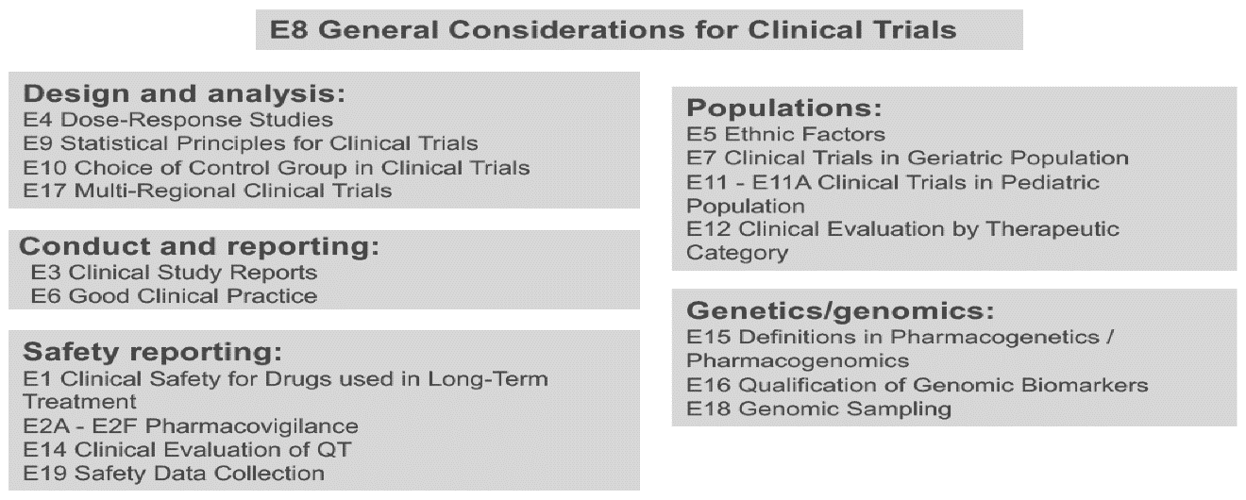  *This diagram will be updated as new ICH guidelines are finalized or updated. | 意見或建議：  類別 勾選  Issue  Question  Suggestion  Topic not addressed  Typographical Error  Not applicable  Other
ANNEX 3: | SELECTED EXAMPLES OF CRITICAL TO QUALITY FACTORS | 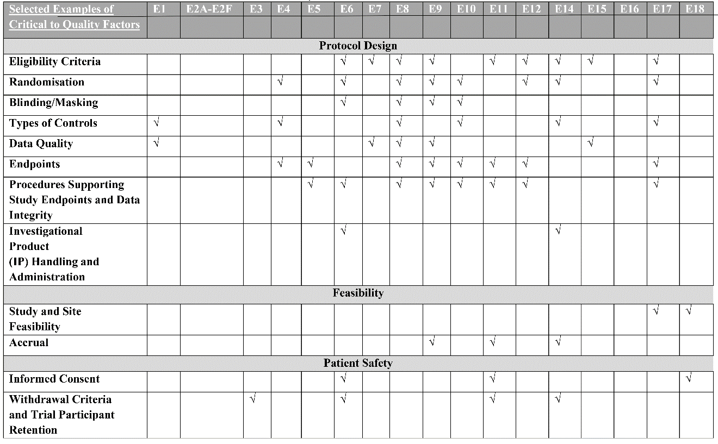  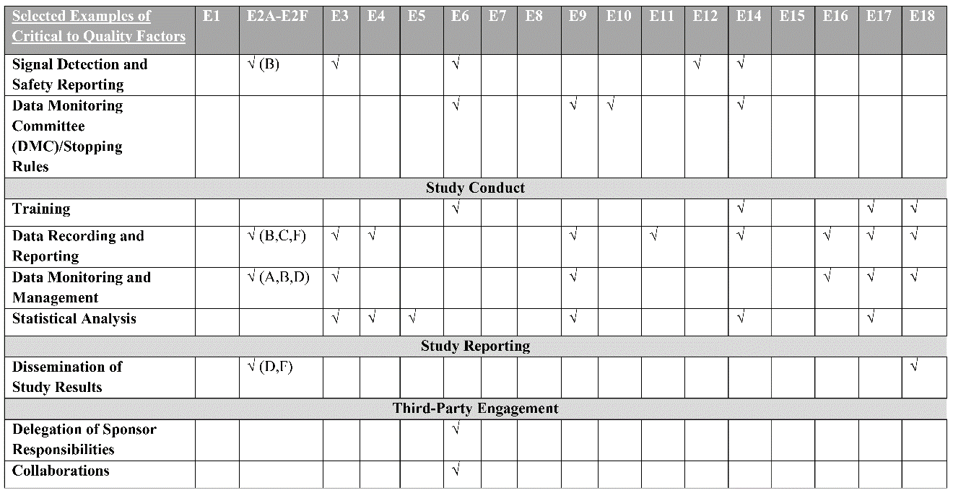  *This chart will be updated as ICH guidelines are finalized or updated.

